Let’s jump right in with a simple example

Example 1: Adding a label to a form
Add a reference to the VSTControls.dll library
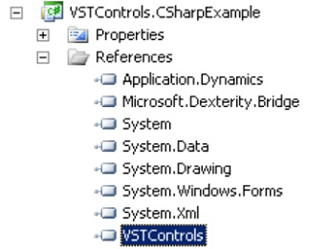

Create a VSTControls object
Create component object ie. Label component
Add the Label object to the VSTControls object, specifying the Window and location

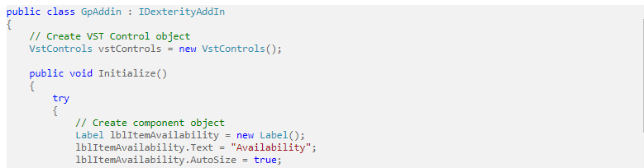
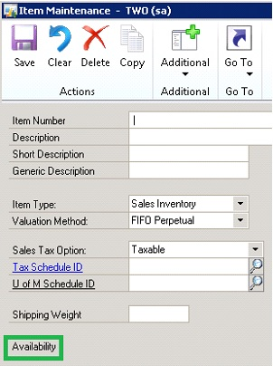

Example 2 : Add a TextBox
Create a TextBox object and add it to the Item Maintenance Window
Add an AfterLeave event to the ITEMNMBR field.
When the AfterLeave event is fired, read the ITEMNMBR value and set the font and text of the TextBox
based on the ITEMNMBR field value
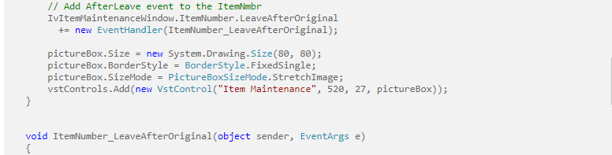
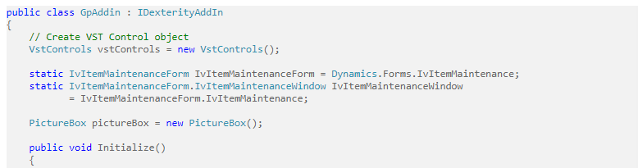

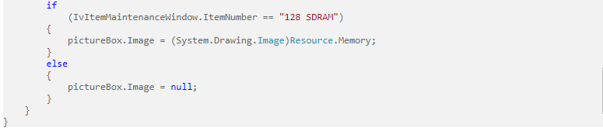

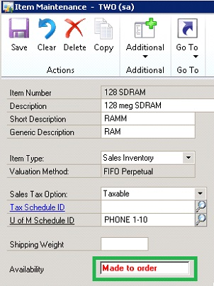

Example 3 : Add pictures
Create a Picture object and add it to the Item Maintenance Window
Add an AfterLeave event to the ITEMNMBR field.
When the AfterLeave event is fired, read the ITEMNMBR value and set the image of the picture object
based on the ITEMNMBR field value
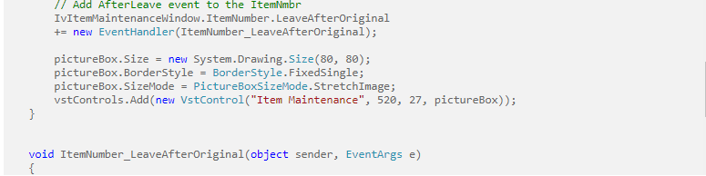
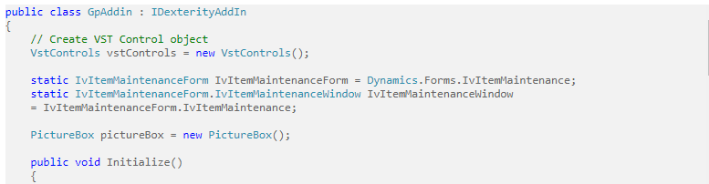

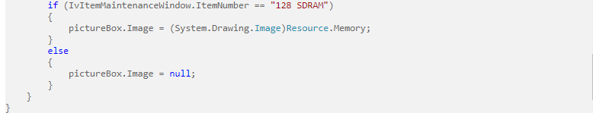

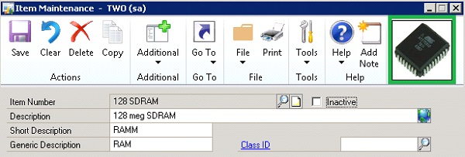

Example 4 : UserControls
Finally, the VST Controls library can be used to develop utilities that improve the VST Control functionality
When adding an object to a GP window, the XY coordinates of the object must be specified. To assist with this, a UserControl called PositionLocator was developed and can be added to a GP Window via VST Controls.
Once the GP window is opened, the PositionLocator is displayed, along with the current cursor XY location
A developer can then use these XY coordinates when placing further objects onto a GP window
